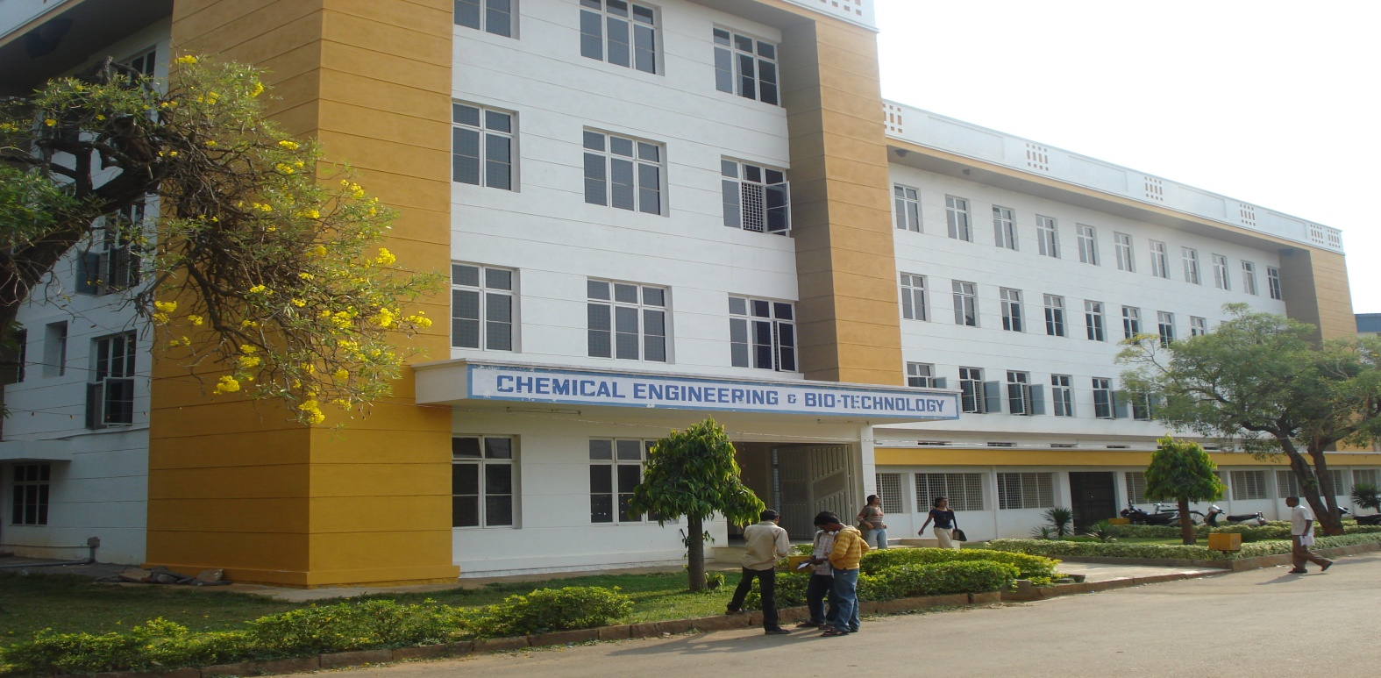
1
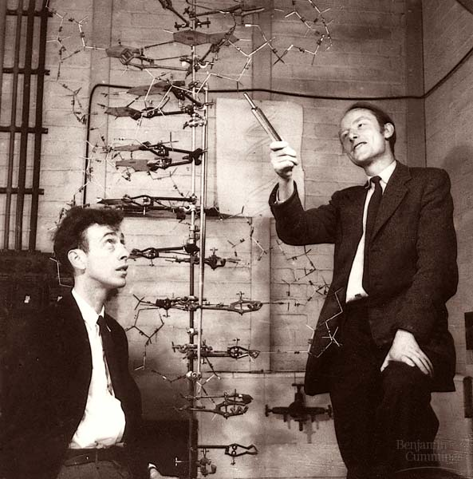
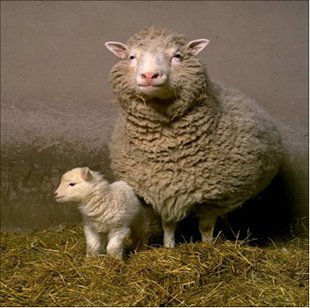
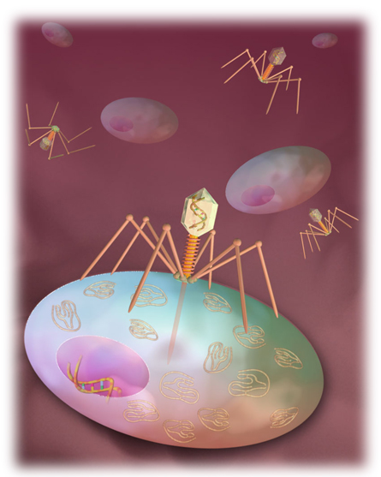
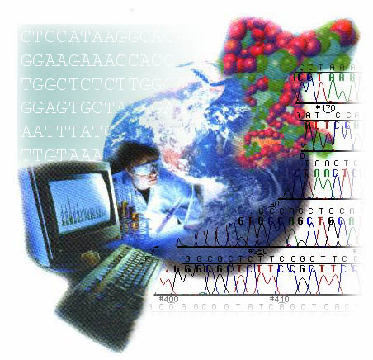
Mission
To provide competent, self-reliant trained manpower required to meet the challenges in research and development, and large scale application of Biotechnology in the areas of agriculture, environment, health care and industry for socio – economic development.

DEPARTMENT OF BIOTECHNOLOGY
Da phage injecting knowledge to the lives…

